Title of the Paper Goes Here: Capitalize the First Letter of Major Words, Centered, 14-Point Times New Roman, on the Second Line from the Top Margin, Preferably not More Than 3 Lines Long

Hui Deng, Shanwu Wang∗, Siqin Hu, Shuaiyu Xue, Pinyan Huang, Hongxiang Yu, Chong Zhou∗
Shanghai Institute of Applied Physics, Chinese Academy of Sciences
Shanghai 201800,China
denghui@sinap.ac.cn; wangshanwu@sinap.ac.cn; husiqin@sinap.ac.cn; xueshuaiyu@sinap.ac.cn huangpinyan@sinap.ac.cn; yuhongxiang@sinap.ac.cn; zhouchong@sinap.ac.cn;

ABSTRACT

The molten salt reactor (MSR) is the only reactor type that employs liquid nuclear fuel. The flowing fuel salt generates volumetric internal heat sources through self-heating, significantly affecting the system’s heat transfer characteristics. In this study, computational fluid dynamics (CFD) is employed to systematically investigate the flow and heat transfer characteristics of molten salt with internal heat sources within the core channels of a 150 MW-class MSR. The primary contents include: validation of the applicability of the k-epsilon realizable turbulence model for high Prandtl number molten salts; elucidation of the effects of internal heat sources on the friction factor and Nusselt number, showing that traditional friction factor correlations and Nusselt number correlations without internal heat sources can exhibit maximum relative deviations of up to 17% and 54%, respectively, in the transitional flow regime; while Nusselt number correlations developed for internal heat source fluids agree well with CFD results, with deviations kept within 11%. The primary innovation is the introduction of a novel internal heat source implementation method utilizing microwave heating, which achieves a significant improvement in power density compared to conventional AC electric heating technologies. A multiphysics coupled simulation framework (COMSOL-Fluent joint simulation) is established, which validates the equivalence between non-uniform heat source distribution and ideal uniform conditions with respect to Nusselt number and pressure drop (ΔP), with deviations maintained within 3%. This research provides crucial theoretical support for the thermal-hydraulic safety analysis of MSRs, and the proposed microwave heating method opens a novel pathway for experimental studies on internal heat sources in high Prandtl number molten salts.

KEYWORDS
MSR; Internal Heat Source; CFD; Nusselt number ;Microwave Heating

INTRODUCTION

As a Generation IV nuclear energy system [1] the Molten Salt Reactor (MSR) possesses notable advantages, including thorium-uranium fuel breeding, operation without water cooling, atmospheric pressure operation, and high-temperature output. Unlike traditional reactors, the MSR utilizes liquid fuel salt, which simultaneously functions as both the coolant and the fuel. This dual function leads to distinct thermal-hydraulic behaviors, especially under low Reynolds number conditions. During nuclear reactions, the molten salt exhibits the unique physical characteristic of internal heat generation due to self-heating, resulting in significant differences in heat transfer characteristics under low Reynolds number conditions compared to conventional fluids, and exerting a considerable influence on graphite temperature [2]. Research on the flow and heat transfer of fluids with internal heat sources primarily encompasses three aspects: theoretical modeling, experimental investigation, and numerical simulation. Theoretical and numerical studies focus on the derivation of analytical solutions and the establishment of semi-empirical correlations, whereas experiments serve as a crucial approach for testing and validating the applicability of empirical relationships.

Early research in this area primarily focused on analytical methods. Poppendiek et al. [3, 4] applied the superposition principle to solve the problem of heat transfer with internal heat sources in both laminar and turbulent pipe flows, thus laying the theoretical foundation for the Nusselt number associated with internal heat sources. Sparrow et al. [5, 6]further developed analytical solutions for temperature distribution based on idealized boundary conditions. However, many researchers contended that, in most practical scenarios, the treatment of boundary conditions and heat source distributions is far from ideal. With the ongoing advancement of CFD tools, research efforts have progressively shifted towards the prediction of complex operating conditions. Cammi et al. [7]were the first to use COMSOL software to perform preliminary assessments of multiphysics coupling between thermal-hydraulics and neutronics in MSRs, while Lelio Luzzi et al.[8] compared COMSOL and FLUENT, completed model validation, and demonstrated both the accuracy of FLUENT calculations and the suitability of its k-ε turbulence model for simulating heat transfer in molten salt. Fiorina et al. [9]developed improved wall functions for wall treatment in Reynolds-Averaged Navier-Stokes (RANS) turbulence models, which significantly improved the accuracy of temperature field predictions.

Despite significant advancements in computational resources, empirical correlations for the Nusselt number continue to serve as a crucial bridge between theoretical developments and engineering applications, owing to their simplicity and practical utility. In recent years, the Di Marcello et al.[10] incorporated the latest turbulent flow and convective heat transfer formulations by Kays and Churchill, and for the first time proposed an empirical correlation for the Nusselt number applicable to fluids with internal heat sources (see Table Ⅰ). Lelio Luzzi et al.[8] further validated the accuracy of this correlation through simulations of the Molten Salt Breeder Reactor (MSBR). Using the OpenFOAM platform and the superposition principle, Fiorina et al.[9] introduced a correction factor φ (see Table Ⅰ) for the Nusselt number of fluids with internal heat sources, expressing it as a function of the Reynolds number and Pr number to modify conventional Nusselt number correlations and reflect the influence of internal heat sources. Di Lecce et al.[11] employed OpenFOAM to validate the correction factor proposed by Fiorina, and further proposed a Nusselt number correction factor for fluids with internal heat sources that possesses broader applicability (see Table Ⅰ). Here, j_{w} denotes the wall heat flux density; Q_{av} denotes the power density of the molten salt; D represents the pipe diameter; r₀ represents the pipe radius; Nu_{Qav+jw} denotes the total Nusselt number; Nu_{jw} denotes the Nusselt number when only wall heat flux is present; and Nu_{Qav} denotes the Nusselt number when only the internal heat source of the molten salt is present.
Table I. The Nu relation of the fluid with an internal heat source
References | Correlation | Reynolds number | Prandtl number
Poppendiek[3] |  |  | _
Di Marcello[10]
Fiorina[2]

Di Lecce[11]

For a long time, empirical correlations for the Nusselt number of fluids with internal heat sources have not been experimentally validated, primarily due to limitations in internal heat source implementation methods and a lack of relevant measurement data. In early studies, Inman[12], Kinney[13], Michiyoshi[14], and others implemented internal heat source experiments by applying alternating current electric heating to NaCl aqueous solutions. However, this approach suffered from two major limitations: (1) the internal heat source power density was low, resulting in a fluid temperature rise of only about 5K, which was insufficient to simulate the high heat flux conditions of MSRs. Additionally, these experiments only measured radial and axial temperature distributions, lacking critical data such as heat transfer coefficients and friction factors; (2) the experimental fluid was an aqueous solution, whose physical properties (2.2 < Pr < 6.0) differ significantly from those of molten salt (Pr > 10). Therefore, it is imperative to develop new heating methods to enable internal heat source experiments with high-Pr number molten salts, thus facilitating progress in this area of experimental research.

Based on the above analysis, the presence of internal heat sources introduces significant challenges to the engineering design of MSRs, highlighting the necessity for comprehensive and systematic investigation into the effects of internal heat sources. Firstly, a comparative analysis was conducted to assess the accuracy of various CFD turbulence models. The models were validated using established Nusselt number correlations for cases without internal heat sources, thereby demonstrating the suitability of the realizable k-ε turbulence model.To support the optimization of molten salt reactor design, a 150 MW-class reactor core channel model was developed using ANSYS Fluent. The effects of internal heat sources on the Nusselt number and frictional pressure drop were systematically investigated across a Reynolds number range of 3.3×10³ to 5.9×10⁴. The applicability of the empirical correlation proposed by Di Marcello et al. was validated, and the error risk boundaries of conventional Nusselt number correlations were identified, revealing that the maximum relative deviation can reach up to 52% in the transitional flow regime. Meanwhile, the evaluation of friction factor correlations indicated that the relative errors of the McAdams, Blasius, and Guo and Julien [15]formulas were all within 15%. However, the potential impact of cumulative pressure drop errors on the engineering design of the reactor core should not be overlooked. Accordingly, this study further developed an empirical friction factor correlation that better matches practical conditions. Finally, this study proposes an innovative approach for realizing internal heat sources using microwave heating. This method offers significant advantages, including high power density and the elimination of electrode corrosion, thereby effectively overcoming the limitations of conventional electric heating technologies in molten salt applications. By integrating COMSOL multiphysics simulations with Fluent numerical calculations, the feasibility of microwave heating in molten salt media was systematically validated. Comparative analyses with ideal uniform internal heat source scenarios were performed, providing a solid theoretical foundation and technical support for experimental investigations involving high Prandtl number molten salts.

SINGLE-CHANNEL MODELING

Figure 1. (a) Schematic Diagram of the Single-Channel Model and (b) Schematic Diagram of Mesh Generation

Based on the single-channel design of a 150 MW-class liquid molten salt reactor core[16] (see Fig. 1a), racetrack-shaped channels were excluded from the modeling process, and the graphite channel was simplified as a hexagonal prism with a central hole. Taking advantage of the symmetry of the core channel, only the axisymmetric 1/6 segment of the hexagonal prism was modeled in three dimensions, as illustrated in the Fig. 1. The model parameters are as follows: channel radius (R = 0.06 m), height (H = 3.0 m), and graphite flat-to-flat distance (D = 0.18 m).

The governing equations were discretized using the finite volume method with a pressure-based steady-state solver, and the SIMPLEC algorithm was employed for solving the coupled velocity–pressure equations. The convective terms were discretized using a second-order upwind scheme. To ensure computational accuracy, the convergence criterion was set to a residual of less than 1×10⁻⁶.
The physical properties of molten salt are provided in Table Ⅱ. The inlet was specified as a mass flow rate inlet with a molten salt temperature of 933.15 K, while the outlet was defined as a pressure outlet with a static pressure of 0 Pa. Coupled heat transfer boundary conditions were applied at the interface between molten salt and graphite walls. Symmetry boundary conditions were imposed on symmetry planes, and all other surfaces were set as adiabatic. In liquid MSRs, 92.5% of the power is deposited in the molten salt and 7.5% in the graphite. Additionally, the axial normalized power distribution of molten salt and graphite in the core (see Fig. 2) indicates a non-uniform internal heat source distribution.

Table Ⅱ. Physical properties of Molten salt and graphitic

Parameter | Salt | Graphite
Type | LiF-BeF2-ZrF4-UF4-ThF4 | IG-110
Density/ kg·m−3 | 2757.9-0.46454×T(K) | 1783
Specific heat/ J·kg−1·K−1 | 2386 | 1700
Heat conductivity/ W·m−1 ·K−1 | 1.4 | 65
Viscosity / kg·(m·s) −1 | 3.6×10⁻⁶exp(7043.24/T(K)) | ―

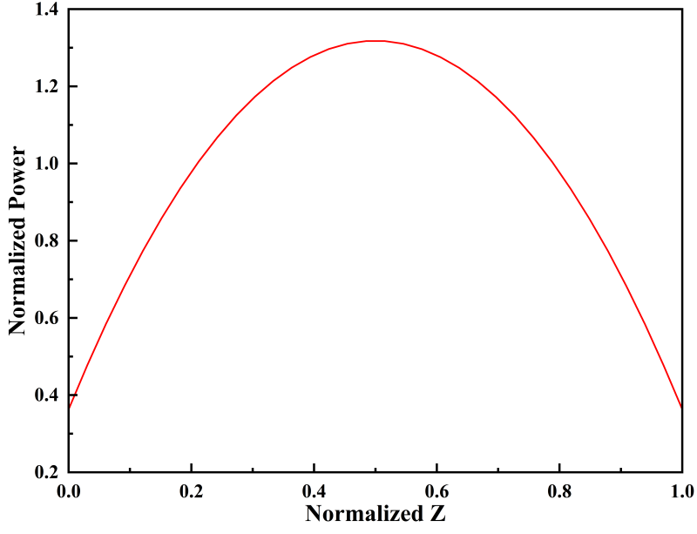
Figure 2. Axial Normalized Power Distribution Curves of Molten Salt and Graphite

To ensure the accuracy of the computational results, a mesh independence analysis was conducted. A multi-region structured hexahedral meshing approach was employed, in conjunction with the Realizable k-ε turbulence model and Menter-Lechner near-wall treatment. Sensitivity analysis was performed by comparing five different mesh sets, ranging from 0.12 million to 3.2 million cells, to obtain the average channel heat transfer coefficient h and the temperatures at outlet locations A, B, and C (with coordinates (0, 0, 3), (0, 0.015, 3), and (0, 0.03, 3), respectively). The results are presented in Table III. The analysis shows that when the mesh size exceeds 2.5 million cells, both the average heat transfer coefficient and the outlet temperatures at points A, B, and C become stable. Considering both computational accuracy and cost, a mesh with 2.5 million cells was finally selected for the subsequent numerical simulations.
Table Ⅲ. Grid-independent analysis

Case | Mesh quantity/W | Average heat exchange coefficient h/(W/(m² ·K)) | Point A temperature/(℃) | Point B temperature/(℃) | Point C temperature/(℃)
1 | 12 | 9606.793965 | 697.79 | 698.63 | 708.1
2 | 39 | 9736.953611 | 698.13 | 699.06 | 707.48
3 | 180 | 9838.221363 | 698.38 | 699.20 | 707.15
4 | 250 | 9861.942829 | 698.39 | 699.21 | 707.09
5 | 320 | 9866.665051 | 698.29 | 699.23 | 707.08

RESULTS AND DISCUSSION

Based on the numerical simulation scheme established in Section 2 and taking into account the unique physical properties of molten salt, it is essential to first validate the accuracy of the selected turbulence model (Realizable k-epsilon) and its near-wall treatment approach (Menter-Lechner). For this purpose, the numerical simulation results at different Reynolds numbers were compared with the empirical correlations for the Nusselt number of molten salt under conditions without internal heat sources.
In liquid-fueled MSRs, the molten salt flow enters the laminar regime only under special operating conditions such as startup and shutdown, during which mixed convection effects are significant and require separate investigation. Under most normal operating conditions, however, the molten salt predominantly exhibits transitional or turbulent forced convection. Therefore, this study focuses on simulation and analysis of the transitional and turbulent flow regimes. The numerically determined Darcy friction factor and Nusselt number were also discussed in detail.

3.1. Selection of Turbulence Model

Owing to the distinctive physical properties of molten salt, it is essential to further validate the accuracy of the selected numerical model. Currently, only empirical Nusselt number correlations for molten salt without internal heat sources have been experimentally validated; thus, using these empirical correlations to validate the numerical model is particularly persuasive. Accordingly, under conditions without internal heat sources, this study selected representative cases with Reynolds numbers of 5×10³, 7×10³, 9×10³, 1.5×10⁴, 2×10⁴, 3×10⁴, 4×10⁴, 6×10⁴, 8×10⁴, and 1×10⁵. The average Nusselt number in the reactor core channel was calculated for each case and compared with both the classical Gnielinski correlation [34] and the correlation by Yu et al. [35], as presented in Fig. 3. The comparison indicates that the relative deviation between the Fluent simulation results and the Gnielinski correlation is within 7%, while that with Yu et al.'s correlation remains within 13%. These results suggest that the k-epsilon realizable turbulence model, when combined with the Menter-Lechner near-wall treatment approach, can reliably simulate heat transfer in high Prandtl number molten salt media. This finding is consistent with the conclusions reported by Lelio Luzzi et al.[8].

Figure 3. (a)Comparison of Fluent results and Gnielinski relations
and (b) Fluent results and Yu Relations

3.2. Thermal-Hydraulic Analysis of 150 MW-Class Molten Salt Reactor Core Components

Furthermore, a systematic investigation was carried out on the flow and heat transfer characteristics of molten salt with internal heat sources in reactor core components under forced convection at various operating powers to elucidate the impact of internal heat sources on system performance. The operating conditions are presented in Table IV.

Table Ⅳ. Single component working condition

Case | Entrance mass flow M/(kg/s) | Molten salt average power density Q_{ave}/(W/m³) | Graphite average power density Q_{IG}/(W/m³) | Re number
1 | 0.15 | 7.2×10⁶ | 6.5×10⁴ | 3.3×10³
2 | 0.2 | 9.6×10⁶ | 8.7×10⁴ | 4.4×10³
3 | 0.3 | 1.4×10⁷ | 1.3×10⁵ | 6.6×10³
4 | 0.5 | 2.4×10⁷ | 2.2×10⁵ | 1.1×10⁴
5 | 0.8 | 3.8×10⁷ | 3.5×10⁵ | 1.8×10⁴
6 | 1 | 4.8×10⁷ | 4.4×10⁵ | 2.2×10⁴
7 | 1.5 | 7.2×10⁷ | 6.5×10⁵ | 3.3×10⁴
8 | 1.8 | 8.6×10⁷ | 7.9×10⁵ | 4.0×10⁴
9 | 2 | 9.6×10⁷ | 8.7×105 | 4.4×10⁴
10 | 2.3 | 1.1×10⁸ | 1.0×106 | 5.1×10⁴
11 | 2.68 | 1.3×10⁸ | 1.2×10⁶ | 5.9×10⁴

3.2.1. Frictional resistance characteristics

In this study, the effect of internal heat sources on the frictional pressure drop within the channel was investigated, and the results are represented by the calculated Darcy friction factor. The formula for the Darcy friction factor is as follows:
(1)

Numerous researchers have extensively studied the Darcy friction factor for fluids without internal heat sources. Some classic correlations applicable to smooth circular tubes are as follows:
The correlation proposed by Guo et al. [15], valid for 10³ < Re < 10⁸:

(2)

The correlation proposed by McAdams, valid for 3×10⁴ < Re < 10⁶:

(3)

The correlation proposed by Blasius, valid for Re < 3×10⁴:

(4)

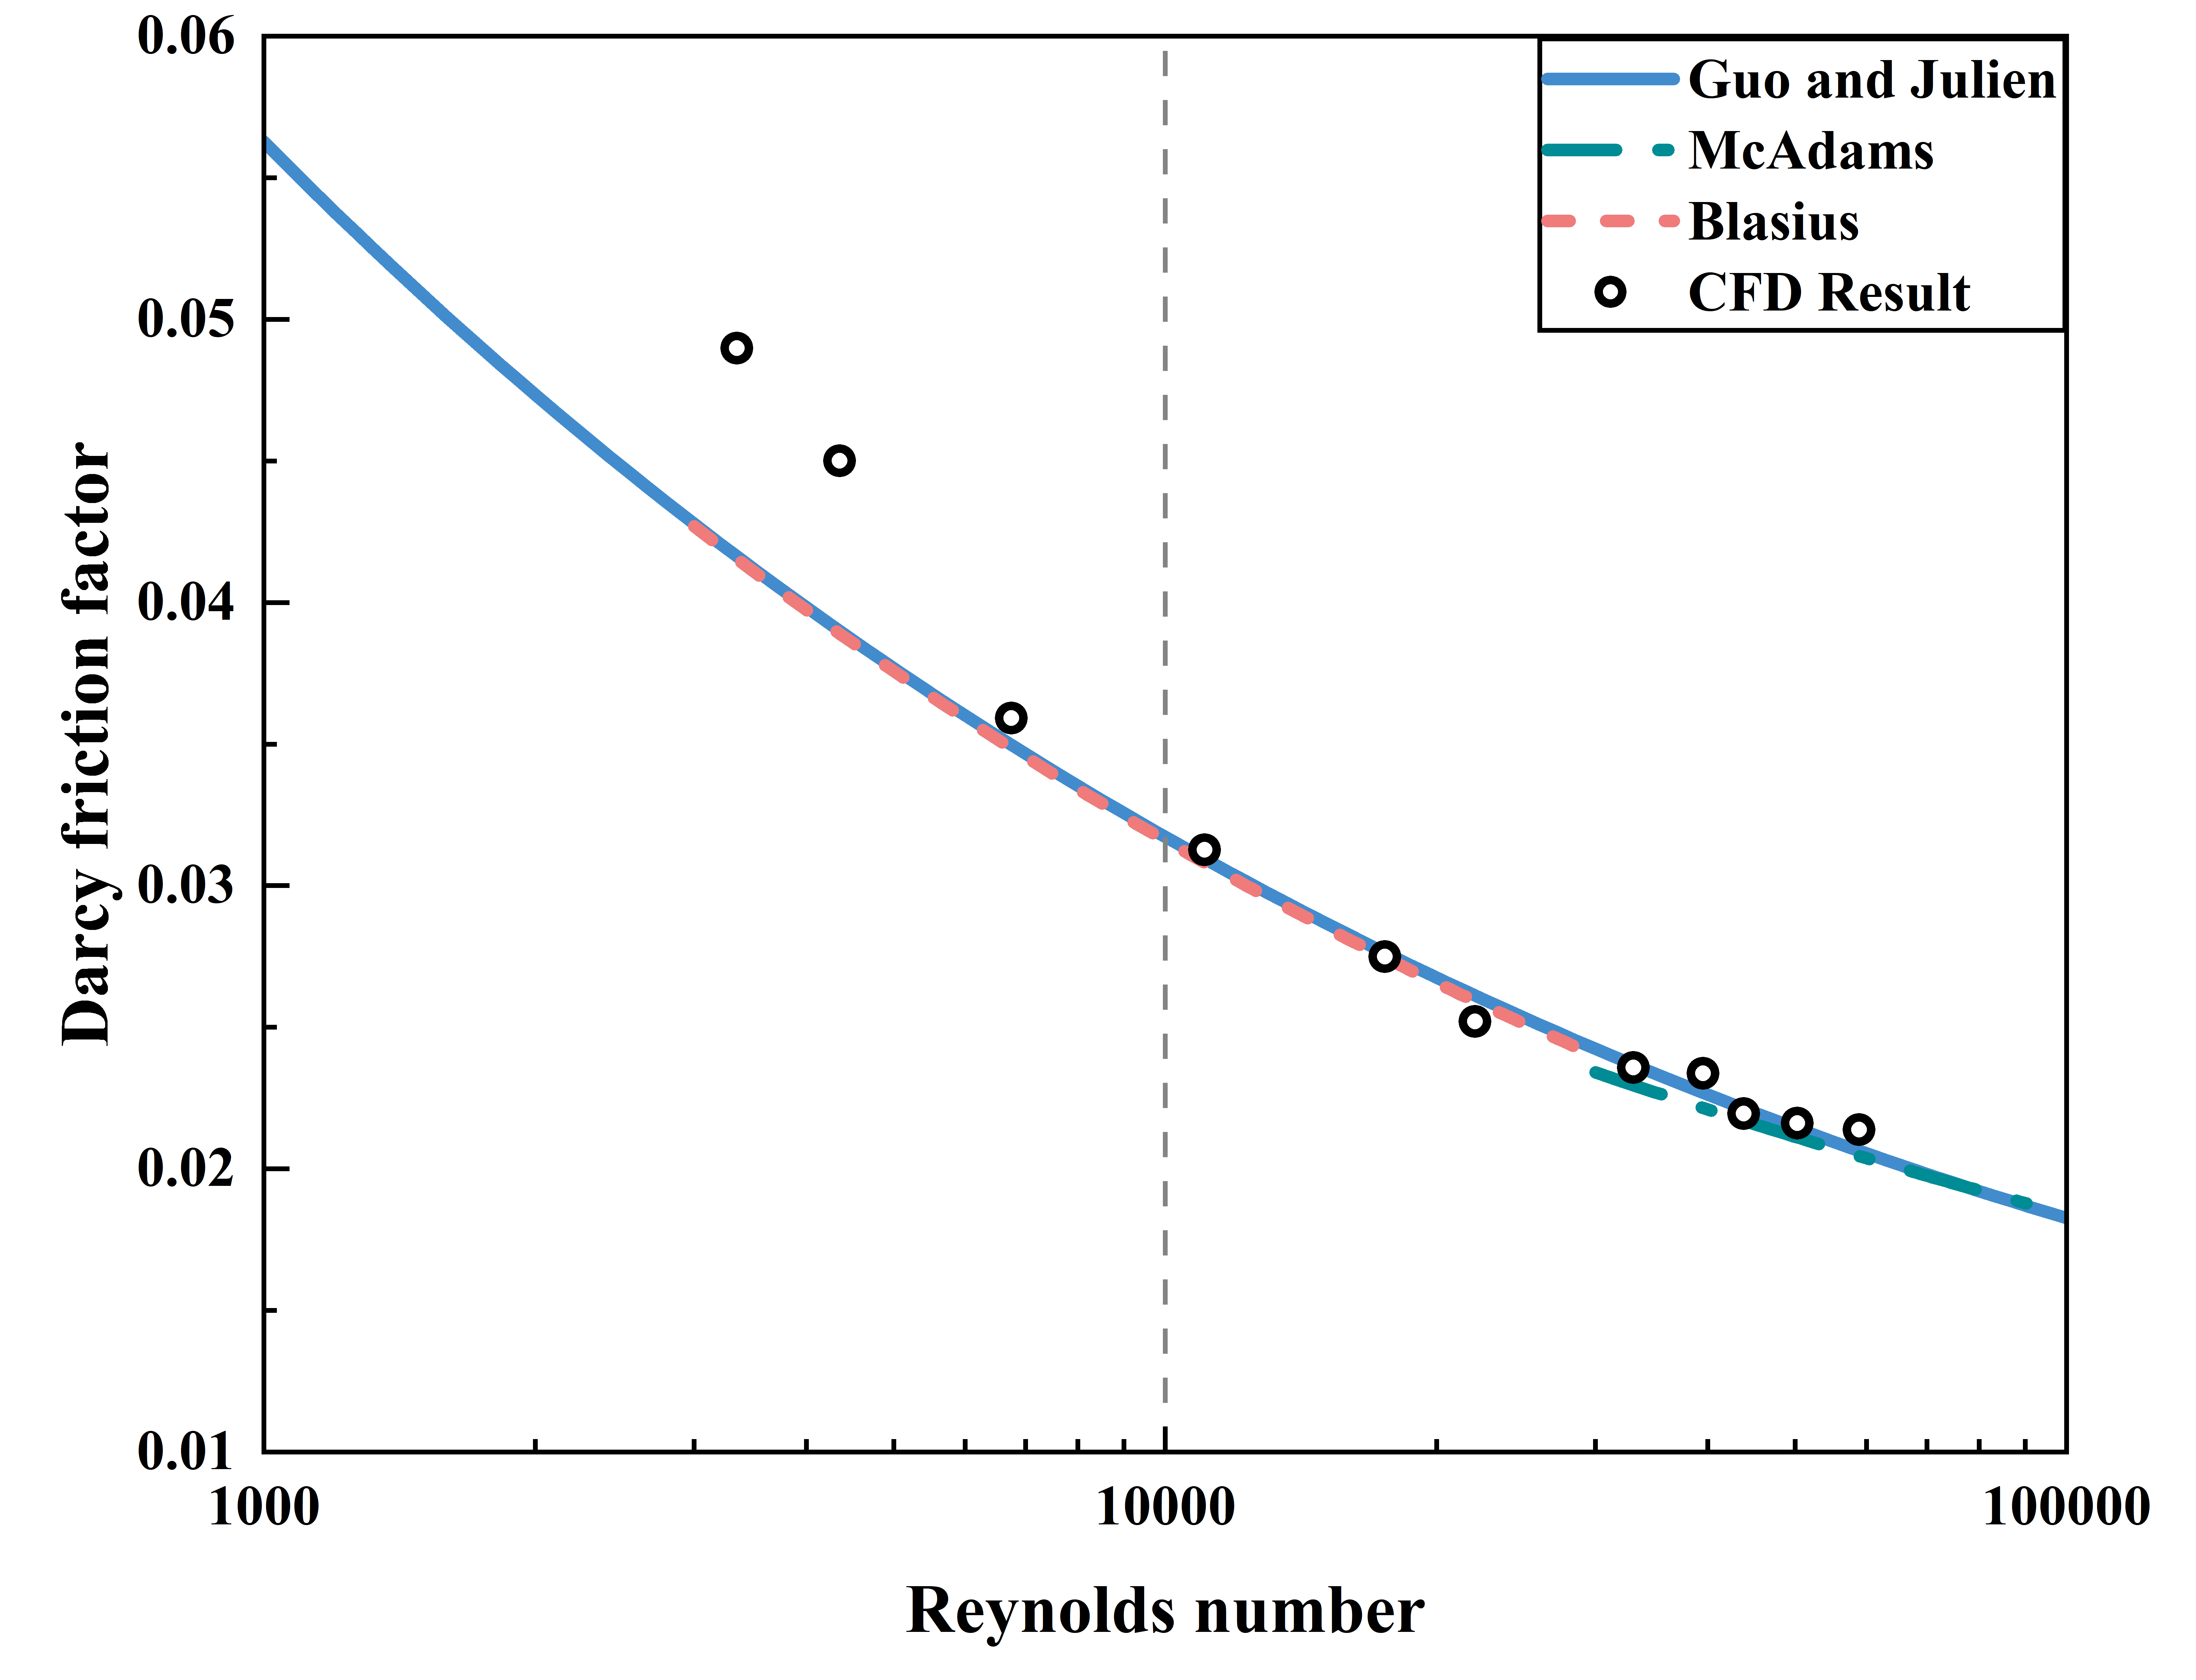
Figure 4. Comparison diagram of the Darcy friction factor

The Darcy friction factor f obtained from CFD simulations was compared with the values calculated using Equations (2), (3), and (4), as shown in Fig. 4. Overall, the CFD results exhibit good agreement with the classical correlations represented by Equations (2), (3), and (4). In the transitional flow regime, the maximum deviations between the CFD results and Equations (2) and (4) can reach up to 15%. In the turbulent flow regime, the maximum deviations between the CFD results and Equations (2), (3), and (4) are 4%, 5%, and 3%, respectively. These findings indicate that, in the transitional flow regime, the presence of internal heat sources has a relatively significant effect on the Darcy friction factor within the core channels.

3.2.2. Applicability of empirical correlations for the Nusselt number

Despite the availability of abundant computational resources today, simple heat transfer correlations are still needed in engineering applications as intermediate tools for predicting graphite temperature hotspots and substantially reducing computational costs. To derive an empirical Nusselt number correlation suitable for engineering practice, this study uses CFD to obtain Nusselt number values and compares them with empirical correlations for molten salts without internal heat sources, as summarized in references, as well as with correlations accounting for internal heat sources. To avoid the influence of entrance effects, only the average Nusselt number in the fully developed region is considered for analysis. The corresponding results are shown in Fig. 5.

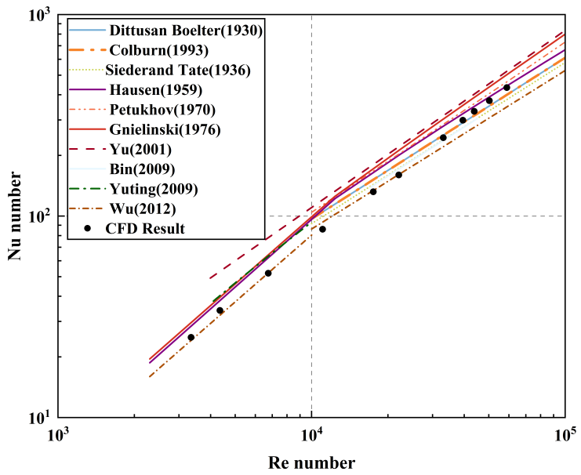
Figure 5. Comparison between CFD results and empirical Nusselt number correlations for cases without internal heat sources

Traditional empirical correlations for the Nusselt number show significant dispersion in both the transitional and turbulent flow regimes, thereby increasing the uncertainty associated with engineering applications. In the transitional regime at low Reynolds numbers, the average Nusselt number of molten salts containing internal heat sources is noticeably lower than that predicted by conventional empirical correlations. For instance, the widely recognized Gnielinski [34] correlation, known for its high accuracy, overestimates the Nusselt number by up to 54%. In contrast, the correlation developed by Wu et al. shows better agreement with simulation results in the transitional regime, with deviations contained within 16%; however, greater discrepancies are observed at higher Reynolds numbers. Wu et al.'s transitional regime correlation was fitted to Silverman’s [11] experimental data for LiF-BeF₂-ThF₄-UF₄ molten salt, but the influence of internal heat sources was not considered. The relatively low experimental results may be attributed to considerable temperature losses at low flow velocities, as well as the formation of a thermal resistance layer caused by corrosion of the pipes by molten salt, both of which reduce the heat transfer coefficient. Therefore, conventional empirical correlations are no longer applicable for molten salt flows with internal heat sources.

The Nusselt number correlations proposed by Di Marcello [59], Fiorina [47], and Di Lecce [48] are established for fluids with uniform internal heat sources under fully developed flow conditions. In this study, the results from Fluent numerical simulations are in good agreement with these correlations (see Fig. 6). For transitional flow, the maximum deviation between the Di Marcello correlation and the CFD results is 4%. In the turbulent flow regime, the maximum deviations between the CFD results and the correlations of Di Marcello [59], Fiorina [47], and Di Lecce [48] are 11%, 10%, and 2%, respectively, with corresponding average deviations of 5%, 4%, and 2%.

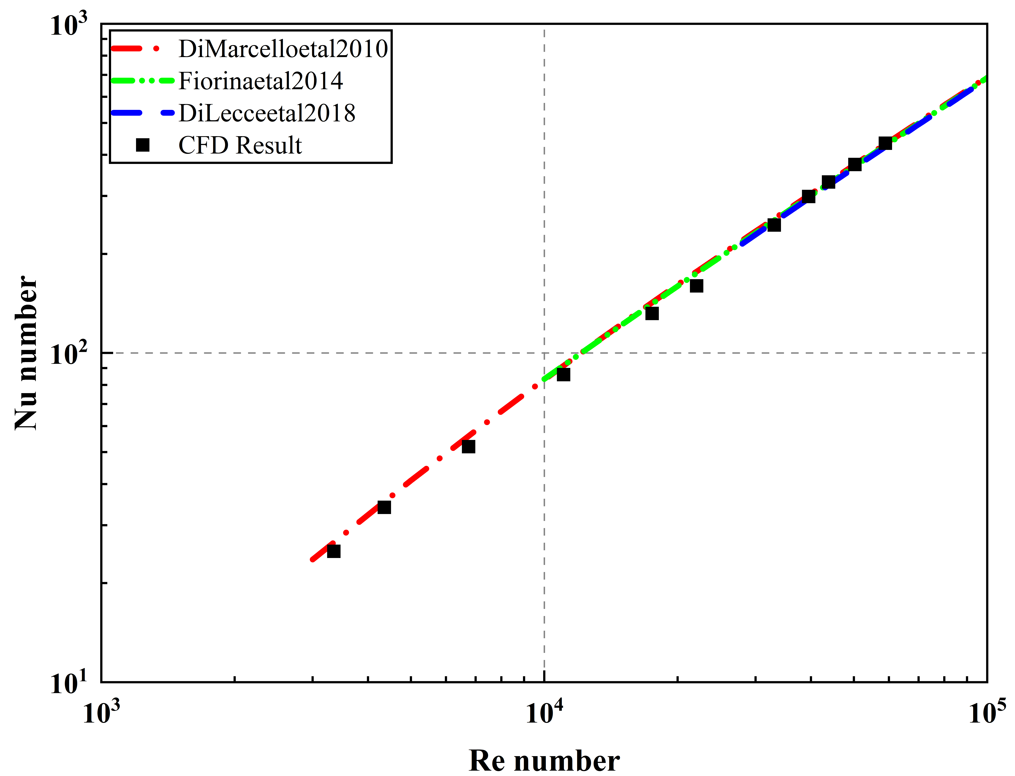
Figure 6. Comparison between CFD results and the correlations presented in Table Ⅰ

These studies demonstrate that the presence of internal heat sources does not significantly affect the hydrodynamic characteristics. However, internal heat sources do induce distinct convective heat transfer behavior, making conventional empirical correlations unsuitable. Importantly, even in the presence of non-uniform internal heat sources, the Nusselt number correlations developed by Di Marcello, Fiorina, and Di Lecce remain valid provided the flow is fully developed.

3.3. Thermal-Hydraulic Analysis of 150 MW-Class Molten Salt Reactor Core Components

Ideally, achieving a uniform distribution of internal heat sources within the molten salt is desired; however, this is challenging in a microwave field. Even prior alternating current experiments [12-14]failed to realize genuine uniformity. In practice, this study primarily focuses on the flow and heat transfer characteristics of a single component. Accordingly, the research emphasis has shifted to comparing the differences in wall heat transfer and frictional pressure drop between microwave-induced and uniformly distributed internal heat source scenarios, under the condition of equal total internal heat source power. Specifically, the analysis encompasses parameters such as the average wall temperature (T_{w}), wall heat flux density (j_{w}), mainstream average temperature (T_{f}), and the frictional pressure drop (∆P) of a single component.

The experimental pipeline has been fully designed, and power was applied to the test section using a microwave generator. In addition, the microwave heating process was numerically simulated using COMSOL software. Fig. 6 presents a schematic diagram of power deposition, where the microwave power is assumed to be uniformly distributed along the longitudinal axis and to exhibit an annular distribution in the radial direction. For analytical purposes, the radial region is equally divided into ten segments.

Figure 6. Schematic power distribution of microwave heating

As the computational analysis by Lelio Luzzi et al. [8] has demonstrated that COMSOL's numerical results for heat transfer problems can involve considerable errors, in this study, the power distribution results obtained from COMSOL were exported and partially simplified. These processed results were then used as input for subsequent heat transfer simulations conducted with Fluent. Fig. 7 presents the radial power distribution, with a minimum power density of 8.6×10⁷ W/m³ and a maximum value reaching 6×10⁸ W/m³.The temperature difference between the channel inlet and outlet reaches 40 K, demonstrating a substantial increase in power density compared to conventional alternating current heating methods.

The CFD results for case 1 (uniform internal heat source) and case 2 (microwave heating) are presented in Table V. Under microwave heating, both the Nusselt number and pressure drop are essentially consistent with those observed for the uniform internal heat source scenario, with discrepancies within 3%. This fully demonstrates the feasibility of the proposed design and enables accurate prediction of the heat transfer characteristics and frictional pressure drop of the component, thus providing an important reference for future experimental investigations.

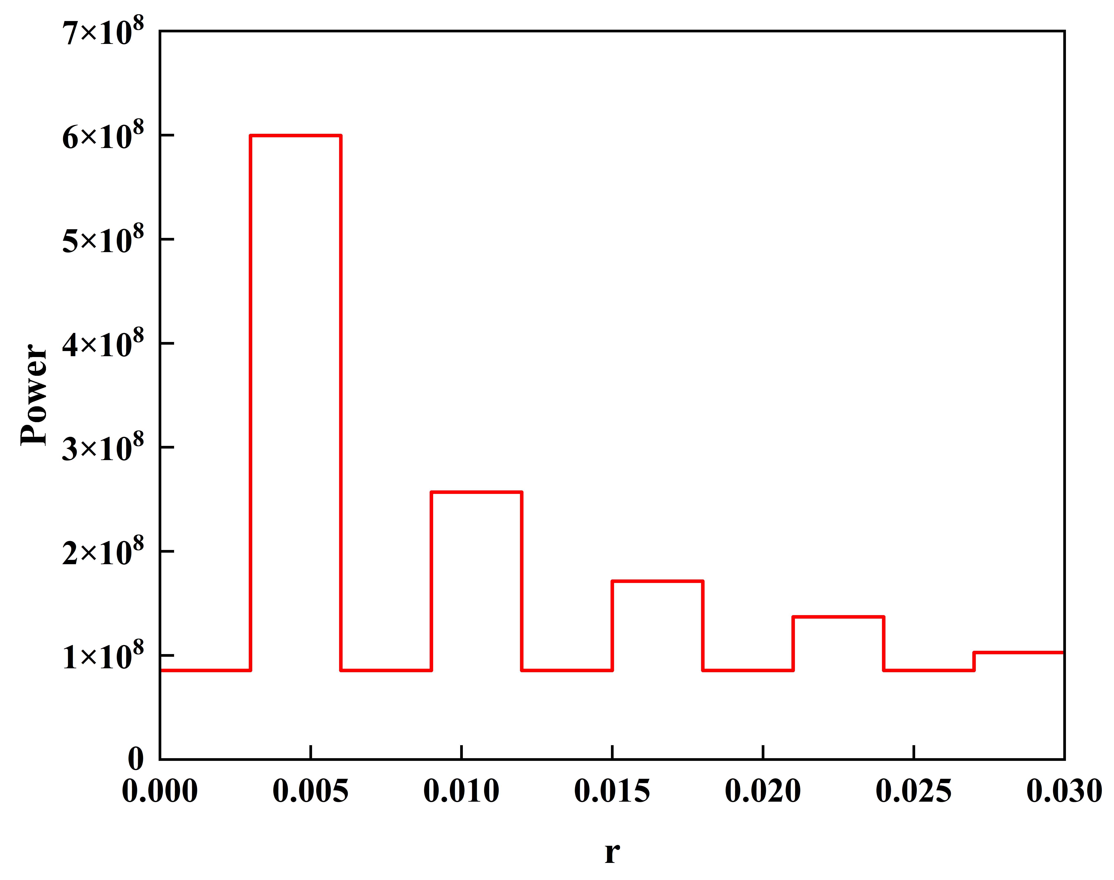
Figure 7. Diagram of microwave radial power distribution

Table Ⅴ. Microwave heating internal heat source working condition table

Case | Average wall temperature T_{w}/K | Average fluid temperature T_{f}/K | Wall heat flux j_{w}/(W/m2) | Nusselt number | erro | Friction pressure drop ∆P/(Pa) | error
1 | 973.15 | 953.15 | 156651 | 336 | － | 4741 | －
2 | 974.36 | 953.68 | 156651 | 325 | 3% | 4838 | 2%

CONCLUSIONS

This study systematically investigated the distinct thermal-hydraulic characteristics of molten salt containing internal heat sources in 150 MW-class molten salt reactor components, and examined the feasibility of utilizing microwave heating to realize the desired distribution of internal heat sources. The inherent self-heating characteristics of molten salt not only influence the internal flow and heat transfer behavior of core components, but also markedly modify the distribution and criteria of temperature hotspots, thereby presenting new challenges for the thermal design of reactor core assemblies. Nevertheless, due to the current lack of sufficient numerical and experimental data in this area, the further development of this research is crucial for refining the theoretical design framework of MSRs and providing guidance for future experimental studies. The main conclusions are summarized as follows:

- The accuracy of the Realizable k-epsilon turbulence model, together with the Menter-Lechner near-wall treatment approach, for the numerical simulation of flow and heat transfer in high Prandtl number molten salt media was systematically validated over the Reynolds number range of 5×10³ to 1×10⁵.
- The computational results demonstrate that the influence of internal heat sources on the friction factor is negligible. However, at lower Reynolds numbers, the error associated with traditional empirical formulas (Eq. (2) and (4)) can be as high as 17%. Accordingly, it is recommended that a Reynolds number correction term be introduced in future investigations to prevent the accumulation of errors in core pressure drop calculations. In addition, conventional empirical Nusselt number correlations for molten salt without internal heat sources are no longer suitable for molten salt with internal heat sources. At low Reynolds numbers, the error can reach up to 54%, which would significantly compromise the prediction of temperature hotspots within the core channels. CFD results indicate that the Nusselt number correlations proposed by Di Marcello, Fiorina, and Di Lecce, which account for the effect of internal heat sources, have deviations within 11% and offer relatively high accuracy; however, further experimental validation remains necessary.

- For high Prandtl number molten salt experiments with internal heat sources, a non-corrosive, high-power-density approach utilizing microwave heating to establish the internal heat source distribution was proposed. The microwave heating power distribution was simulated and simplified using COMSOL, and subsequently integrated with heat transfer and fluid flow calculations in Fluent. The results indicate that the deviations in the average channel Nusselt number and frictional pressure drop (ΔP) compared to the ideal uniform internal heat source scenario are both within 3%. This confirms the feasibility of the proposed technical approach and offers a theoretical foundation for future experimental investigations.

ACKNOWLEDGMENTS

The authors express their gratitude to the Youth Science and Technology Project (SINAP-YXJH-202403) of the Shanghai Institute of Applied Physics, Chinese Academy of Sciences for providing financial support to facilitate this research endeavor.

REFERENCES

- Kelly, J.E., Generation IV International Forum: A decade of progress through international cooperation. Progress in Nuclear Energy, 2014. 77: p. 240-246.
- Fiorina, C., Impact of the volume heat source on the RANS-based CFD analysis of Molten Salt Reactors. Annals of Nuclear Energy, 2019. 134: p. 376-382.
- Poppendiek, H.F. and L.D. Palmer. FORCED CONVECTION HEAT TRANSFER BETWEEN PARALLEL PLATES AND IN ANNULI WITH VOLUME HEAT SOURCES WITHIN THE FLUIDS. 1954.
- Poppendiek, H.F. and L.D. Palmer. Forced Convection Heat Transfer in Pipes with Volume Heat Sources Within the Fluids. 2013.
- Siegel, R. and E.M. Sparrow, Transient Heat Transfer for Laminar Forced Convection in the Thermal Entrance Region of Flat Ducts. Journal of Heat Transfer, 1959. 81(1): p. 29-36.
- Sparrow, E.M. and R. Siegel, Laminar Tube Flow with Arbitrary Internal Heat Sources and Wall Heat Transfer. Nuclear Science and Engineering, 2017. 4(2): p. 239-254.
- Cammi, A., et al., Assessment of COMSOL Capabilities to Analyse the Thermo- Hydrodynamic Behaviour of the MSR Core. 2009.
- Luzzi, L., et al., An approach for the modelling and the analysis of the MSR thermo-hydrodynamic behaviour. Chemical Engineering Science, 2010. 65(16): p. 4873-4883.
- Fiorina, C., et al., Thermal-hydraulics of internally heated molten salts and application to the Molten Salt Fast Reactor. Journal of Physics: Conference Series, 2014. 501.
- Di Marcello, V., A. Cammi, and L. Luzzi, A generalized approach to heat transfer in pipe flow with internal heat generation. Chemical Engineering Science, 2010. 65(3): p. 1301-1310.
- Di Lecce, F., et al. CFD-Based Correlation for Forced Convection Heat Transfer in Circular Ducts of Internally Heated Molten Salts. in 2018 26th International Conference on Nuclear Engineering. 2018.
- Inman, R.M., Experimental study of temperature distribution in laminar tube flow of a fluid with internal heat generation. International Journal of Heat and Mass Transfer, 1962. 5(11): p. 1053-1058.
- Kinney, R.B. and E.M. Sparrow, Turbulent Pipe Flow of an Internally Heat Generating Fluid. Journal of Heat Transfer, 1966. 88(3): p. 314-321.
- Michiyoshi, I., Y. Kikuchi, and O. Furukawa, Heat Transfer in a Fluid with Internal Heat Generation Flowing through a Vertical Tube. Journal of Nuclear Science and Technology, 1968. 5(11): p. 590-595.
- Guo, J. and P.Y. Julien, Modified log-wake law for turbulent flow in smooth pipes. Journal of Hydraulic Research, 2003. 41(5): p. 493-501.
- HU Siqin,ZHOU Chong,ZHU Guifeng,et al.Development and validation of a thermal-hydraulic analysiscode for dual cooled assemblies in molten salt reactors[J].NUCLEAR TECHN IQUES,2024,47(09):090602. DOI:10.11889/j.0253-3219.2024.hjs.47.090602.

